3M 360 Encompass System – Phase II

IP Coding and Workflow Management

**1.** **Overview** 1

**2.** **Inpatient Coding Functionality – Generic** 2

**3.** **Launch-in Mode Details** 20

**4.** **360 Worklist Mode Details** 22

1. **Overview – Revision 6.6**
   1. The following requirements describe the functionality for inpatient coding and inpatient workflow management in the 3M 360 Encompass System. Except where noted, all functionality described is anticipated for delivery for the beta testing customer sites.
   2. This version of the requirements represents an integration of multiple related requirements documents and refactoring that has occurred through the ongoing beta implementation projects. This document replaces all previous versions of the IP workflow and management requirements (combines and updates the requirements contained in the "IP CODING FINALIZED" and "Coding Workflow Management and Dashboards FINALIZED").
      1. Screen captures have been used from the AHIMA demo system
      2. Except where noted, the screen captures represent the expected graphical design and UI elements of the software
      3. Wherever necessary and possible, additional images have been mocked up to illustrate design and functionality concepts
   3. There are two modes of operation for inpatient coding:
      1. “Launch-in mode” describes how the software operates when a 3rd party abstracting system controls the coding workflow
      2. “360 worklist mode” describes the operation of the software when 360 Encompass will provide the workflow management.
      3. For the most part, both modes are identical in appearance and functionality for coding except where noted. 360 Worklist mode provides extensive dashboard and worklist management features that are not available in launch-in mode.
      4. Each beta site can operate in one mode or the other, but not both.
         1. Future:
   4. Importantly, the 360 coding workflow must have an awareness of whether CDI data exists for the visit as some operations and information will be suppressed if CDI information is not available or permitted for the user.
   5. The visitID displayed in the browser tab as (3M logo + "Visit:" VisitID). 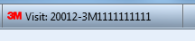
2. **Inpatient Coding Functionality – Generic**
   1. Summary Page

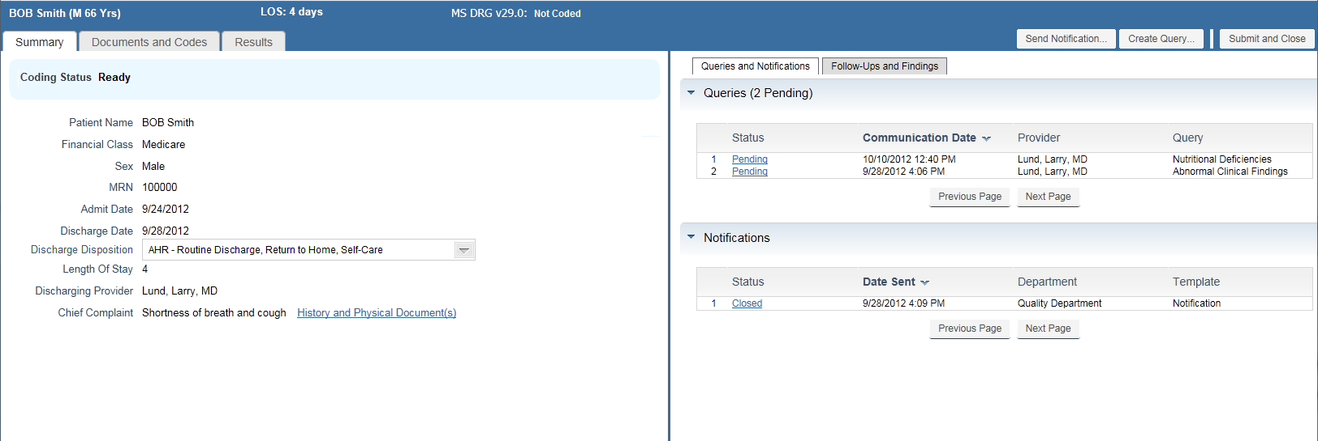

* + 1. Patient Ribbon
       1. Patient Name in format First Name Last Name (no middle name or title included).
       2. LOS in days (same calculation as defined in CDI workflow)
       3. Computed DRG, version and abbreviated description (first 50 chars) of primary grouping results or “Not coded” if DRG has not been established by the coder. Format as follows:
          1. xx DRG vxx.x: Not Coded - if record not coded
          2. xx DRG vxx.x: 690 KIDNEY & URINARY TRACT INFECTIONS W/O MCC
          3. Mouse-over will show current grouper and version, DRG code and description based on the patient’s primary payer (as designed in CDI).
          4. For 360 Encompass, the APR DRG will always be used either as secondary or primary depending on configuration, but regardless the APR DRG and related values need to be calculated and stored. If the APR grouper is used as primary (as in Maryland, New York, and other states), the “preferred secondary” grouper results will be displayed (e.g. MS DRG).
          5. The intention is to always show an APR DRG, SOI, and ROM (either as primary or secondary)
       4. Coding status – display description (3M-defined values of Not Ready, Ready, On Hold, Assigned, Coded)
       5. Patient Name (First Name Last Name – in format sent by ADT) example as displayed below:



* + - 1. Financial Class - description from the patient’s financial class, e.g.”Medicare”.
      2. Sex – display description from sex table, populated by ADT record. Site configurable.
      3. MRN – patient’s Medical Record Number
      4. Admit Date - Date format will be based on enterprise 360 date configuration. (default will be mm/dd/yyyy hh:mm AM/PM)
      5. Discharge Date - Date format will be based on enterprise 360 date configuration. (default format is mm/dd/hh:mm AM/PM)
      6. Discharge Disposition – Editable field. Displays a drop-down list of 3M defined values from discharge status table. The code and description display and the discharge disposition list is sorted in code order.

Example:

01 Home

02 Short Term Hospital

03 Skilled Nursing Facility (SNF)

* + - 1. Length of Stay is the length of stay of the patient being coded in days. Use standard LOS calculation (not based on grouper results). E.g. day of admission counts as 1 day. Day of discharge does not count. Therefore if the patient is in the hospital overnight and discharged the next day, the LOS is 1. Another way of looking at the calculation is how many times did the patient’s stay cross midnight?
      2. Discharging Provider – Show the discharging provider if available with the provider format Last Name, First Name, Credentials (e.g. Lund, Larry, MD). Clicking on the Discharge Summary link jumps to CAC with the Discharge Summary document open. If Discharge summary is not available, the link is not displayed, as follows:  
           
         Discharge Summary Available:    
           
         Discharge Summary Not Available: 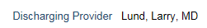
      3. Chief Complaint – Chief Complaint as it came through on the ADT. Clicking on the History and Physical link jumps to CAC with the History and Physical document open. If H&P is not accessible, the link is not displayed.  
           
         History and Physical Available:   
         History and Physical Not Available: 
      4. Principal Diagnosis – displayed below Chief Complaint if present (i.e. if the record has been coded). The formatting will be as the other fields on the summary:
         1. Principal Diagnosis {code} + {description}, e.g. “Principal Diagnosis 486 Pneumonia, Unspecified”
    1. Queries – Same functionality as CDI. Coders will query the physician in the same way and for the same reasons as a CDI reviewer - most often looking for greater specificity in the documentation. The primary difference is that the queries are retrospective. No new templates are required.
       1. Note: behind the scenes, it is important for reporting purposes to track the workflow from which the query was created. If the user is in the CDI workflow, the query record in the DB needs to note that it was generated in CDI (QueryWorkflow = CDI). If the query was generated in the coding workflow, the DB needs to note that it was generated in coding (QueryWorkflow = IP Coding)
    2. Notifications – Same functionality as CDI. Coders will notify in the same way and for the same reasons as a CDI reviewer - most often looking for greater specificity in the documentation. The primary difference is that the notifications are retrospective. No new templates are required.
    3. Follow ups and Findings operate in the same manner as in CDI except that Follow ups and Findings cannot be created or modified. They are for reference only.
       1. There is no Follow-up button at the top as there is in CDI to create new Follow-ups. The links in Follow-ups (under the Status column) go to a read only view of the Follow-up in a pop up window. It is the same as the CDI Follow-up Update window except it is read only with an OK button instead of a save and cancel button. The title reads “Follow-up” instead of “Update Follow-up”.
       2. Findings: Clicking the reference document name will open that document in the “Documents and Codes” tab.
    4. Coding Status History



* + - 1. The coding status panel on the Summary page of the IP and OP workflow will display the current coding status of the record as well as provide the ability to view a history of the visit’s status changes (by providing an expand/collapse control similar to the “findings log” in the CDI workflow.
      2. Each coding status change that is tracked should write a transaction type/user/date/time stamp/record entry point to the database.
         1. As described below, the coding statuses that should be tracked are the status involving user actions:

Assignment of record

Placing record on hold

Coding the record

* + - * 1. Tracking other status changes (such as the transition from Not Ready to Ready) are not required at this time.
      1. The expand/collapse control should appear only if there is content to display. Messages to be displayed in reverse chronological order (most recent first).



* + - 1. Coding Status values are 3M defined as follows:
         1. Not Ready (360 worklist mode only)
         2. Ready
         3. Assigned (360 worklist mode only)
         4. On Hold (360 worklist mode only)
         5. Coded
      2. Syntax for messages are:
         1. Assigned to [user (First Name Last Name)] by [user (First Name Last Name)] on [dd/mm/yyyy hh:mm AM/PM] (date/time to be displayed in 360 enterprise date configuration format)

{assigned comment}

* + - * 1. On Hold by [user(First Name Last Name)]] on [dd/mm/yyyy hh:mm AM/PM] (date/time to be displayed in 360 enterprise date configuration format)

{Hold reason}

{hold comment}

* + - * 1. Coded by [user (First Name Last Name)]] on [dd/mm/yyyy hh:mm AM/PM] (date/time to be displayed in 360 enterprise date configuration format)
      1. Ready and Not Ready status changes do not need to be tracked.
      2. The coding status provides a history of the visit as it has moved through the HIM department:
         1. *Scenario: David Owen was the original coder. He had to place the chart on hold due to the missing discharge summary, and he is noting that the discharging physician Dr. Lund is away on vacation that Dr. Lund’s assistant is tracking down the discharge summary. David Owen assigned the record to his manager, Irene, since he would be not be at work the next day. The next morning, having validated that the discharge summary has been received into the system, Irene assigns the record to another coder, Stacy Mckenna, who then completes the coding.*
      3. When a coding status entry is added into the Visit Coding Status History table, the method of coder access to the record (Record Entry Point) will also be stored in the DB in the Visit Coding Status History Table. This will be utilized in a report to identify coders who potentially ‘cherry picking’ records.
         1. The Record Entry Point values are: 3rd Party Abstractor, Worklist, Patient Search, and Open Visit.
      4. Use a vertical scroll bar if the coding status extends beyond 20 lines. (The example above shows 20 lines)
  1. CDI Reviewer Codes Dialog (applies to both launch-in and 360 worklist modes)



* + 1. When a coder first selects the Documents and Codes page, the coder will be presented with the CDI Reviewer Codes model dialog if:
       1. The Accept Reviewer Codes option is configured to be on for this facility (based on Accept Reviewer Codes global setting). a working codeset from CDI is available
       2. The record has not been worked on in the coding workflow by any coder (i.e. one-time choice only).
    2. Dialog features
       1. CDI Reviewer – listed in the parentheses as the last CDI Reviewer who saved the most recent CDI working codeset. Reviewer name displays as first name last name (e.g. Linda Jordan).
       2. CDI Review Date – This is the date/time of the last review done by the CDI Reviewer using the 360 enterprise date/time configuration setting - default mm/dd/yyyy hh:mm AM/PM
       3. Discharge Date – The date and time of the discharge of the patient in format of 360 enterprise date configuration.
       4. Grouping Information – This is the Working DRG for that visit based on the CDI Reviewer’s codes for the last review.
          1. Diagnosis and Procedure Codes – Principal Diagnosis, Diagnosis, Principal Procedure, and Procedure codes and descriptions from the CDI Reviewer are all listed to inform the coder’s decision on whether to accept the reviewer codes. Long text is used for descriptions. These sections will default to expanded so that the user does not have to expand each one to see it. This is essentially the Coding Summary from the working DRG codeset. All features of the Coding Summary view are available except for ability show evidence for suggested codes (due to the modal dialog).
       5. Accept Reviewer Codes (enabled by default) - When the user presses this button, the CDI Reviewer codes are all copied into the coders final code set.
          1. Codes cannot be copied individually.
          2. Fields copied include all coding data such as POA, physician, and procedure date.
          3. If codes are copied from the CDI Reviewer that match codes that were auto suggested for the Coder, they no longer show up in the Suggested Code list. They become a part of the Accepted Code list.
          4. Accepted/modified/rejected computer assisted coding behavior is stored in the DB to allow reporting of the behavior of individual reviewers (working codes) and coders (final codes). Example report is Coder Agreement Rate.
       6. Discard Reviewer Codes – When user presses this button, the encounter is entered without copying any codes. X – When the X in the upper right hand corner is pressed, the same action as pressing ‘Discard Reviewer Codes’ button is executed. Once a button is selected, the user is not presented this screen again for the encounter.
  1. Documents and Codes Page

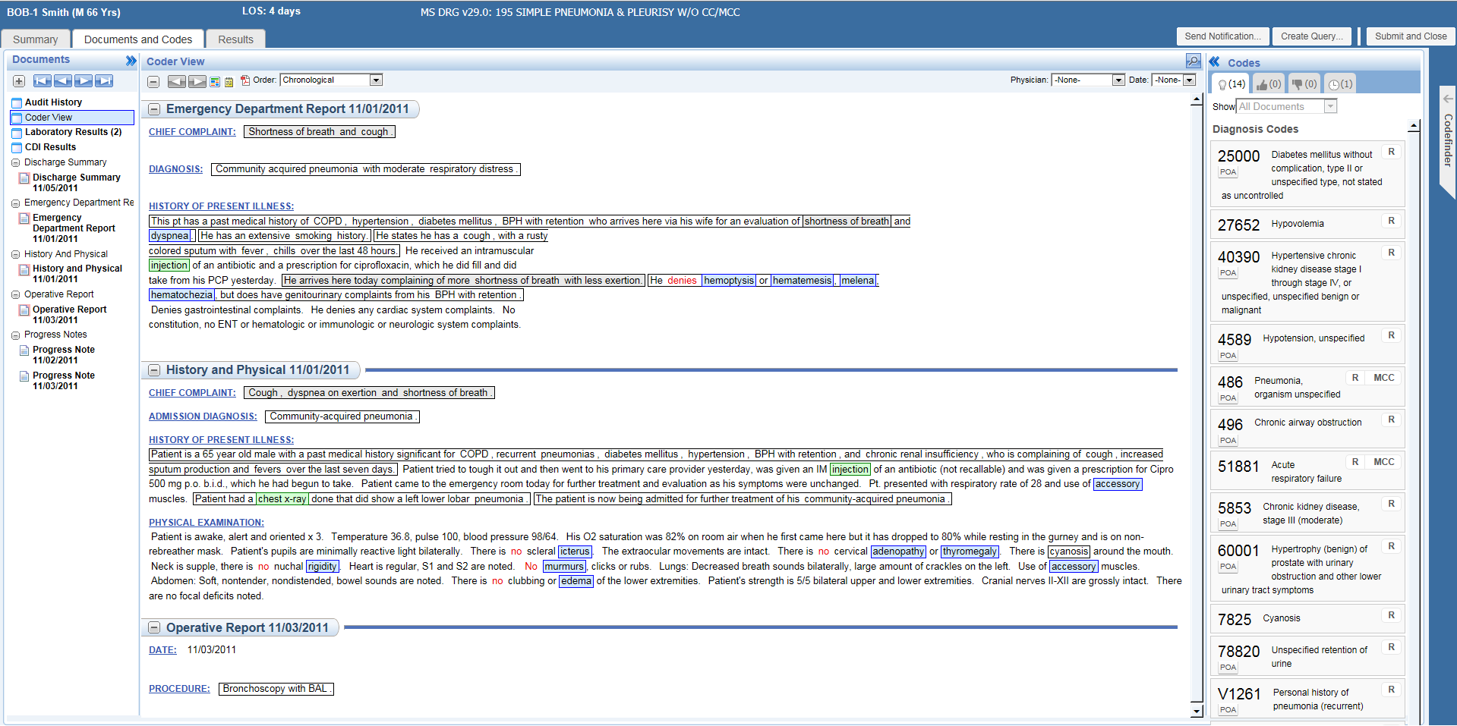

* + 1. The CAC view will be displayed in a single card. The 3M logo will be removed from CAC container. Please refer to the screenshots for more details. The CAC view has 3 panels – Documents, Reading pane, and Codes. The user should be able to resize these 3 panels’ width.
       1. Documents Pane
          1. This collapsible panel is shown on the left side. It is collapsible via a minimize button on the upper right. Title should read “Documents”.
          2. CDI and Coder view and CDI Results will be part of phase II as they exist today.
          3. Review Codes will be renamed to “Audit History”. It will contain a read only view of the document history and documents with notes. It will not contain codes and sources as it does today.
       2. Reading Pane
          1. This non-collapsible pane is shown in the middle of the CAC section. This pane is used to show either the current document or the evidence for a particular code (selected in the codes list). Annotation functionality remains as it is in the July release.

Tool Tip hovers for evidence / annotations within the documents will act as they currently do in CAC.

When the documents pane is collapsed, the user should be able to navigate through documents (sequentially) directly from the reading pane – i.e. the reading pane toolbar should have some mechanism to support navigating thru documents (e.g. some “Previous”, “Next” buttons).

* + - * 1. **Important:** respond to user actions within CAC that invoke Codefinder in the UI, such as coding from a dx or procedure term or when Validate/Recode is selected.

If Codefinder is not popped out, expand Codefinder so that is available for the coder to use.

If Codefinder is popped out, switch focus to the Codefinder browser instance (if possible.

* + - 1. Codes Pane
         1. This collapsible pane is shown on the right side of CAC section.
         2. Title should read “Codes” Tabs inside this pane are

Suggested Codes (default)

Code List

Rejected

Symptom & Historical

* + - * 1. All tabs will show the number of codes in those sections, in the title – e.g. “Rejected (2)”.
        2. Suggested Codes, Code List, and Rejected will show two sub-sections:

Diagnosis Codes

Procedure Codes (shown in that order).

* + - * 1. Code List will also contain a CPT/HCPCS section below the already listed sections if these codes are found in Codefinder.
        2. Symptom & Historical will be divided into two sub-sections:

Symptom Codes,

Historical Codes.

These will be further sub divided into Diagnosis and Procedure sections like the rest of the sections.

* + - * 1. All the codes that have either been accepted (from suggested list) or added by the user (using code finder) will be shown in the “Code List” section.
        2. All the auto-suggested codes that are yet to be reviewed will be shown in the “Suggested Codes” section.

The title also shows the number of codes in that section – e.g. “Suggested (21)”.

When a code is accepted from the suggested list, it disappears and is added to the Code List.

* + - * 1. The user can also set the POA indicator for each code by clicking the “POA” marker for that code.

Clicking the POA marker will show all available values, and the user can choose the appropriate one.

Setting the POA in the Suggested Code list tab triggers an acceptance of the code as well and moves the code to the Code List tab.

* + - * 1. Code description is also shown.
        2. When the coder clicks the 'R' in Codefinder next to a code, the code is highlighted in CAC and the user can then take any desired action on the code (view evidence, reject, etc.).
        3. Code order in the Code List will be the same as in Codefinder.
        4. In the suggested and rejected lists the codes are listed alpha numeric.
        5. CC and MCC indicators are also shown next to the code description. This indicator signifies that this code is a potential CC or MCC for MS DRG.

The indicator for CC and MCC in Codefinder is not impacted by the CAC indicator and will function just as it does today. The indicator will be displayed for each code whether auto suggested or not. The flyover will display “Potential CC” or “Potential MCC.” CAC only shows these indicators if the current grouper is an MS-DRG based grouper (usually determined from Codefinder).

* + - * 1. Show Evidence Button on codes (looking glass):

If the documents have been purged that are needed to show evidence, existing evidence document names and snippets will be shown instead.

* + - * 1. ICD-10: ICD-9 to ICD-10 mappings are not part of CAC. The primary code set will be shown.

If annotations are for ICD-10 and they launch into Codefinder in dual coding mode, Codefinder will retain both code sets, but CAC will only display the primary codeset which in this case would be ICD-10.

* + - * 1. Morphology Codes will be included under the diagnosis section of the Code List.
        2. Document sections in the documents pane that are configurable by client will still be available in this pane in CAC.
        3. In CAC letters will not be shown in any of the code pane lists.
        4. In the reading pane, current functionality will remain:

E = Excluded

S = Symptom

H = History

R = Reviewed/Accepted

C = Confident

* + - * 1. Principal diagnosis and procedure codes are not identified or settable in the Codes Pane. These are handled in Codefinder.

Code List Filter

For the Inpatient Suggested Codes tab, there will be a drop down filter at the top will two options:

Current Documents (codes ordered alpha numeric)

Shows auto suggested codes based on the document the user has currently selected. If they select a different document, this code list will change to reflect codes for the new document shown.

All Documents (codes ordered alpha numeric)

When this option is selected, all suggested codes are listed unfiltered.

Default will be 'Current Documents'.

If the user selects "Coder View" or another view that is not a single document, this filter is limited to "All Documents".

If the coder reverts to a document from a non-document view and they were previously on the 'Current Documents' filter, the filter will go back to 'Current Document'.

* + - 1. **Collapsing and Expanding Panes.** The Documents Pane, Codes Pane, and Codefinder all have collapse/expand capability.
         1. They are collapsed by pressing the minimize button in the upper right hand corner of the pane.
         2. When collapsed they become a sideways button (as Codefinder is shown in this view).

When a sideways button is pressed, the pane expands and the sideways button disappears.

* + - * 1. Collapsing or expanding a pane does not affect any other panes.
        2. The reading pane takes up more or less space changed by other expanding/collapsing panes.
        3. Tooltips:

Tooltips for the minimize buttons for the Documents pane, Codes pane, and Codefinder will read "Collapse Documents", "Collapse Codes", and "Collapse Codefinder" respectively.

Within Codefinder, the Documents Pane, and Reading Pane, existing product tooltips will apply.

Within the Codes Pane the following Tooltips will remain as they do today for the buttons and icons next to each code:

"Validate/Recode" - sideways u turn arrow

"Delete" - reject the code, thumbs down icon

"Show Evidence" - Looking Glass

"Auto-suggested: Review" - "R"

For the "$" on a CPT/HCPCS Code the tool tip is whatever is passed in on the interface to CAC using the CHGCD: tag

The accept button (which is a thumbs up in the design) will have a tooltip of "Accept".

* + - 1. Codefinder
         1. Codefinder is available on the right edge of the 360 frame and is visible only in the Documents and Codes tab, and in the Results tab.
         2. It is not visible in the Summary tab.
         3. Title bar for Codefinder will read “Codefinder”.
         4. The title bar also has a button to pop-out or pop-in the Codefinder from/to the workspace.
         5. In the default CAC view, code finder will be shown in collapsed state. However, the user can open it by clicking the collapsed title. To re-collapse Codefinder, the user would press the minimize button.
         6. Pop-out

The user can pop-out Codefinder by clicking the “Pop-out” button in the title bar.

* + - * 1. The user can minimize the Codefinder by clicking the minimize button in the title bar. When Codefinder is opened, it will slide-in and take up all available vertical height. Horizontally, it will take up as much space is needed to display it fully.
        2. **Done** button (Save Results)

When the coder presses the Done button Codefinder computes if it hasn’t already and goes to the Results tab.

**Critical Information Identified message**

This message appears if the DRG does not match a viable DRG from CDI. The DRG Mismatch language as it appears in the design would display only if the DRG does not match a viable DRG identified by the CDI Reviewer. 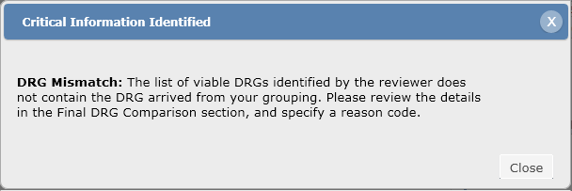

* 1. Results Page
     1. The results page provides the same functionality as the results page defined in CDI.

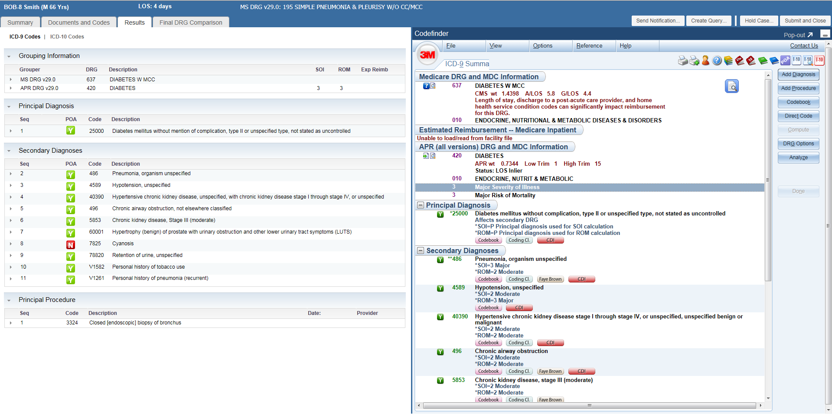

* 1. Final DRG Comparison Page

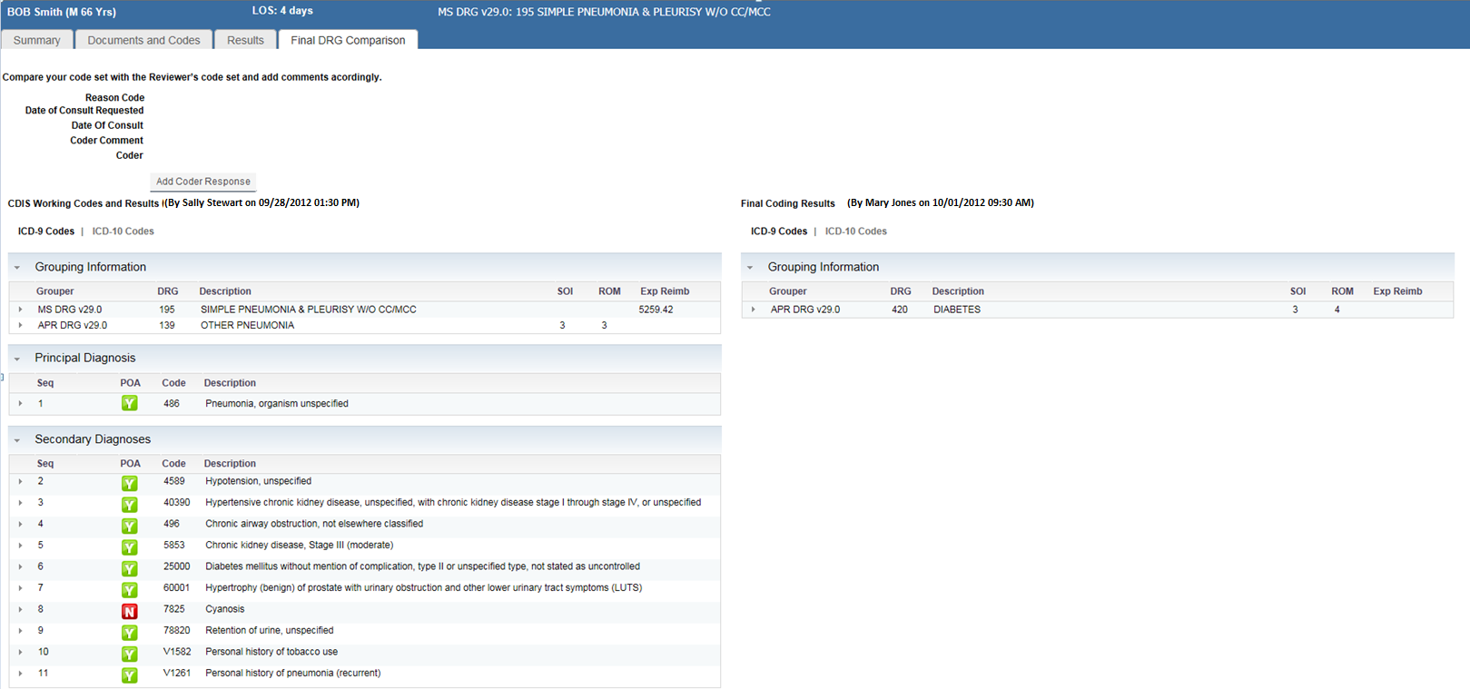

* + 1. Only available if a working grouping result generated in the CDI workflow from the primary grouper exists for the visit, otherwise not available. If subsequent changes to the coding produce a match, the Reason code will be automatically changed to Optimal Selection in the database, and the Final DRG Comparison page will no longer be visible. Any previous Coder Response data to be deleted.
       1. The intent is to allow the coder to enter, add, modify the information at any time, overwriting previous information if necessary. Adding information is accomplished via the Add/Update Coder Response dialog. Only one coder response is necessary but can be modified if necessary.
    2. This tab appears when a DRG is computed which provides a DRG which can be compared to the CDI viable DRGs.
    3. It is available as soon as the encounter is opened if a final DRG was saved previously.
    4. CDI Reviewer list
       1. The title of the CDI Reviewer list of codes shows the CDI Reviewer’s name (First Name Last Name) and the date (in 360 enterprise configuration format) for which those codes were saved as shown.
          1. “CDI Working Codes and Results (by Sally Stewart 09/28/2012 01:30 PM)”
       2. All viable DRGs included any previously selected viable DRGs are listed. If a viable DRG is the same as the CDI Working DRG, the DRG is not included in the Other Selected Viable DRGs list. (see image below)
          1. Additionally selected viable DRG display below the Grouper Information, if there are additional viable DRGs that are different than the DRG listed under Grouper Information. The same DRG is not shown in the Grouper Information section and in the Selected Viable DRG section.
          2. If there is only one DRG selected for viable DRG that is the same as the DRG in the Grouper Information section, the viable DRG section does not display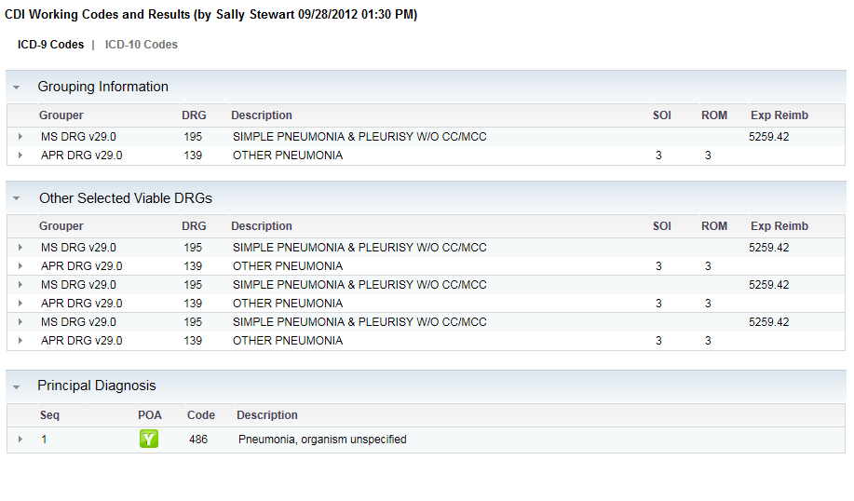

Does not display if no other DRGs. Do not repeat primary Grouper DRG here

Only Primary Grouper DRGs display

* + - 1. Grouping Information contains the working DRG along with the grouper name and version.
      2. Code list
      3. Grouping information contains the DRG grouper name, version, code, and description for primary and secondary grouper. Use existing 360 code summary list from cards for codes.
      4. Coder clicks “Add Coder Response” to add or updated comments, invoking a modal dialog as follows for the coder’s response.

 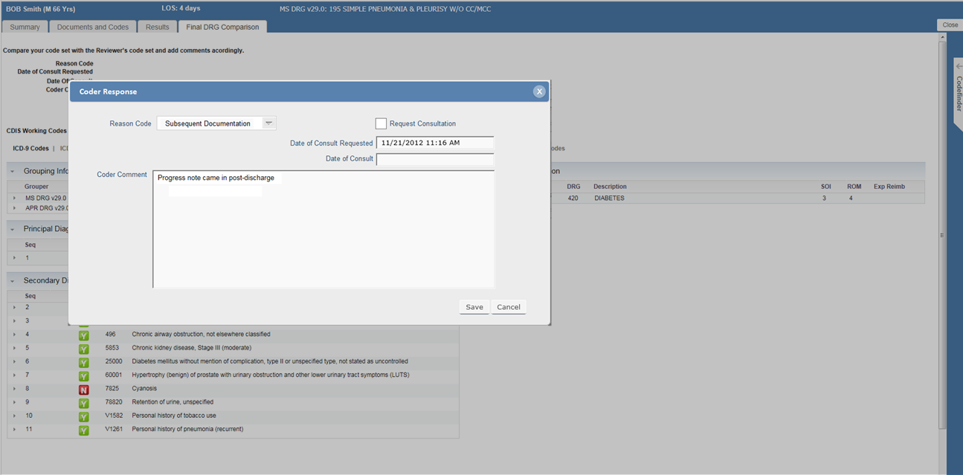

Request Consultation

With

* + - 1. Reason Code specifies reason for difference in DRGs. Use 3M-defined static list as exists in current product.
      2. If the Coder Response dialog is called, Reason code should be a required field (*).
      3. Reason code is set to ‘Optimal Selection’ if the Final DRG matches a viable DRG.
      4. Request Consultation With is optional.
         1. If the coder clicks on the Request Consultation With drop-down list, an alphabetical list of all users with CDI Reviewer role display along with users with Coding Supervisor role display.
         2. Request Consultation With drop-down list defaults to selecting the name of the CDI Reviewer user who created the last CDI working DRG codeset.
         3. The coder may change the default selection in the Request Consultation With drop-down list to another user displayed in the list.
         4. A worklist "Referred for Consultation" is available in the CDI Reviewer workflow.

The CDI Reviewer Worklist template contains a worklist criteria selection for "Referred for Consultation With" drop down-list of all users with a CDI Reviewer Role and Coding Supervisor role.

All, multiple users, a single user, or no users may be selected for "Referred for Consultation". The default is no users selected.3

A visit will not appear on the Referred for Consultation worklist if there is a date entered in the Date of Consult field.

* + - 1. Date of Consult Request – This is a read-only field. This field displays the current date in 360 date format based on enterprise configuration setting when the request consultation box is checked. The data is saved in the database when the save button is pressed.
      2. Date of Consult – this is editable by the coder to record when the consult takes place. It can be left blank until then. The coder may enter the date on the Final DRG Comparison tab. A calendar is available for selection of the consult date. The Date of Consult displays in 360 date format base on the enterprise configuration setting.
      3. Coder Comment – Free text fields where comments can be written by the coder for why DRGs did not match or otherwise.
         1. Coder - When the Save button is pressed on the Coder Response dialog box, the login information of the user logged in (the coder) will be stored in the database along with the reason code, Consultation Request, Date of Consultation Request (current date and time), and Coder Comment.
      4. Comment is always optional.
      5. Save button when pressed commits the reason code, request consultation with, current date and time to Date of Consultation Requested if Request Consultation With contains a selection, and coder comment to the database.
      6. The title of the Final Codes Results shows the coder's name (First Name Last Name format) and the date for which the codes were saved in global enterprise format.

1. **Launch-in Mode Details (Using 3rd Party Abstractor instead of Worklists for workflow control)**



* 1. CDI vs. Coding Only
     1. In launch-in and dashboard/360 worklist mode, the coding workflow needs to be aware of whether the implementation includes CDI or is coding only.
     2. In a Coding Only implementation, the Final DRG Comparison page will not be displayed at any point in the workflow.
        1. This requirement is potentially met by not showing the Final DRG Comparison page unless there is a working DRG from CDI for comparison. In a coding-only implementation, there won’t be CDI results available.
  2. Launch-In Workflow Mode vs. Dashboard Workflow Mode
     1. Launch in mode refers to launching a 360 patient record (inpatient coding workflow) from a 3rd party abstracting system, such as an EHR. Launch-in also describes interaction with 3M abstractors HDM or ClinTrac.
     2. A reverse call to the abstractor so that 360 can control the workflow via the dashboards and worklists as implemented at Memorial Hermann.
     3. Only valid coding statuses are Ready and Coded.
     4. Not Ready, On Hold, Assigned do not apply.
  3. Launch-in Mode Patient Summary (IP Workflow)
     1. Launching in from an Abstractor
     2. When a visit in 360 is launched from an abstractor instead of the 360 worklist, Assign and Hold functionality will not be available. The coder can either code the record or abandon the coding session by closing the browser window. The Submit and Close button is not available until the coder has coded and pressed Done in Codefinder. The Submit and Close will return codes to the abstractor.
     3. If when launching in from an abstractor and the visit record cannot be located in the 360 database, a message will be displayed indicating that the record cannot be found, and the coding session will be abandoned upon the user acknowledging the message.

1. **360 Worklist Mode Details (using 360 Worklists for workflow control)**
   1. Coding workflow
      1. Not Ready

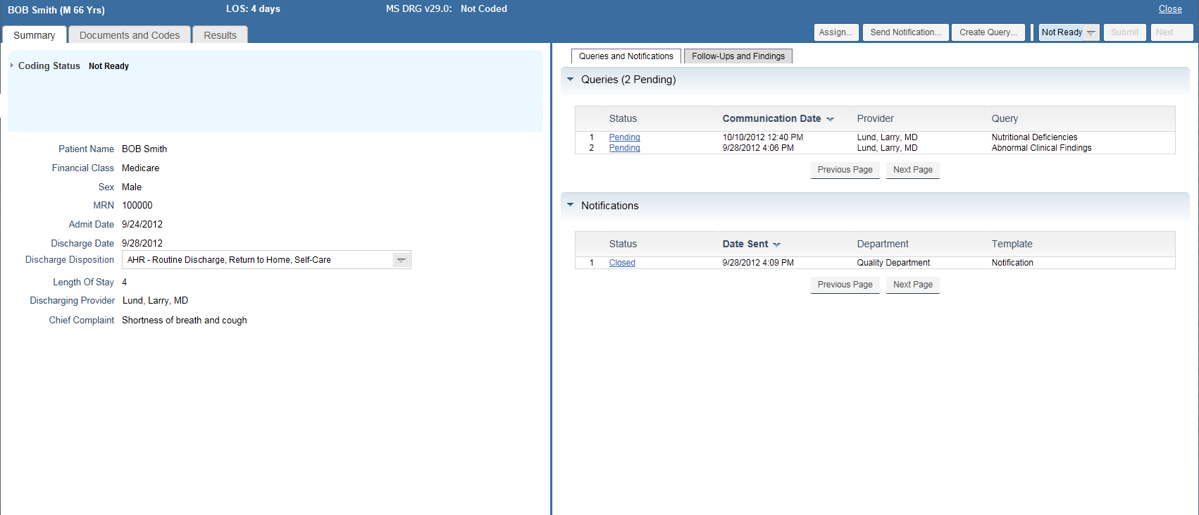

* + - 1. The above image depicts a record that does not meet the criteria for coding readiness. A “Not Ready” record could be accessed via the visit search function in the dashboard.
      2. Available actions:
         1. Set record to "Ready" state for coding. At that point the record would be considered "Ready" and all subsequent available actions, e.g. placing on hold would be available. When IP Coding Worklists are generated or refreshed, a coding status of "Ready" overrides "Coding Readiness Criteria" for worklist generation/refreshing. I.e. 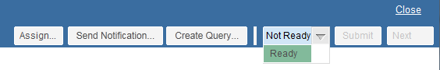

It’s no longer necessary to test the record for coding readiness.

* + - * 1. Assign record to manager/auditor via the Assign action
        2. “Next” is available for managers/auditors only (allowing them to cycle through a worklist and change the status, make assignments, etc. as necessary).



* + 1. Ready

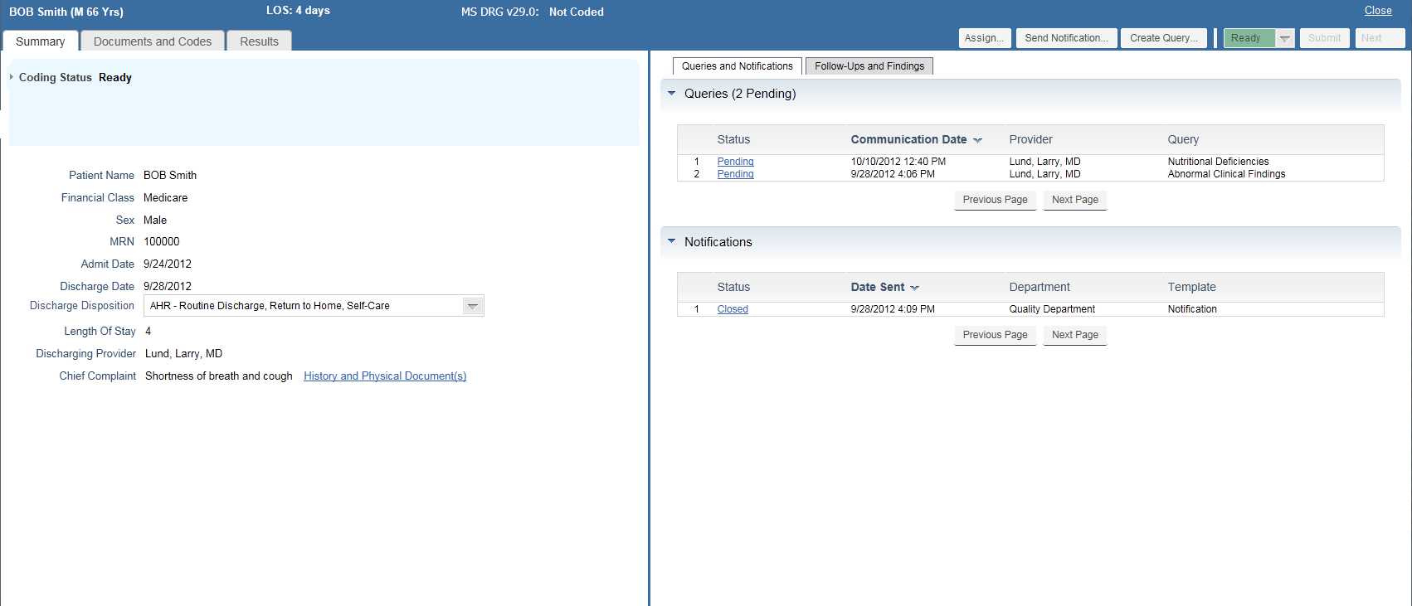

* + - 1. The image above shows a record that is ready to be coded.
      2. Available actions to the coder would be:
         1. Code the record (Submit not enabled unless there is a saved codeset from Codefinder – i.e. “Done”)
      3. Editable Discharge Disposition
         1. The image to the upper left depicts the Discharge Disposition as an editable field. This will be necessary at some customers that rely on HIM coding to determine the discharge status. Note in a launch-in mode, the abstractor will be used to pass the valid discharge disposition to 360. In dashboard/worklist mode, 360 will need to allow the coder to change the disposition.
         2. The edited discharge disposition will be used as the discharge status passed to Codefinder.
         3. Once the record is in a coded state- the discharge disposition cannot be edited. If a record is re-coded and re-submitted, the disposition may be changed if necessary by changing the coding status from coding to another status. Assign to manager/auditor

Error Handling: When a user transitions a record's coding status to 'assigned' or 'hold' when accessing the record from a 360 worklist and interfacing to an abstractor (example, PowerAbstract) that requires sending a request to synchronize the encounter, the following error handling shall occur if the notification to the abstractor fails:

If the User changes the Coding Status from "assigned' or 'hold' and the call to the abstractor fails, a “Coding Status Change Synchronization Failed” dialog box displays.

The dialog box contains the following message “A failure occurred sending the coding status associated with this record to your abstractor. Please press “Retry” to attempt to retry synchronizing the coding status change or press “Cancel” to continue

The following visit data displays below the message: VisitID MRN Patient Name Facility Admit Date Discharge Date

If the user presses “Retry” 360 resends the request to synchronize the coding status again to the abstractor. The user may attempt pressing ‘Retry” button multiple times.

If the user presses the “Cancel” button, the coding status in the visit is not updated in 360 and the 360 workflow continues as if there was not a failure synchronizing. This will result in the coding status on the visit not updated in the 360 DB and the will need to be re-accessed at a later time to complete the coding status change.

* + - * 1. Place the record on hold

Error Handling: When a user transitions a record's coding status to 'assigned' or 'hold' when accessing the record from a 360 worklist and interfacing to an abstractor (example, PowerAbstract) that requires sending a request to synchronize the encounter, the following error handling shall occur if the notification to the abstractor fails:

If the User changes the Coding Status from "assigned' or 'hold' and the call to the abstractor fails, a “Coding Status Change Synchronization Failed” dialog box displays.

The dialog box contains the following message “A failure occurred sending the coding status associated with this record to your abstractor. Please press “Retry” to attempt to retry synchronizing the coding status change or press “Cancel” to continue

The following visit data displays below the message: VisitID MRN Patient Name Facility Admit Date Discharge Date

If the user presses “Retry” 360 resends the request to synchronize the coding status again to the abstractor. The user may attempt pressing ‘Retry” button multiple times.

If the user presses the “Cancel” button, the coding status in the visit is not updated in 360 and the 360 workflow continues as if there was not a failure synchronizing. This will result in the coding status on the visit not updated in the 360 DB and the will need to be re-accessed at a later time to complete the coding status change.

* + - 1. Error Handling: When a user transitions a record's coding status from being on "hold" to "ready" when accessing the record from a 360 worklist and interfacing to an abstractor (example, PowerAbstract) that requires sending a request to synchronize the encounter, the following error handling shall occur if the notification to the abstractor fails:
         1. If the User changes the Coding Status from "hold to "ready" and the call to the abstractor fails, a “Coding Status Change Synchronization Failed” dialog box displays.
         2. The dialog box contains the following message “A failure occurred sending the coding status associated with this record to your abstractor. Please press “Retry” to attempt to retry synchronizing the coding status change or press “Cancel” to continue.
         3. The following visit data displays below the message: VisitID MRN Patient Name Facility Admit Date Discharge Date
         4. If the user presses “Retry” 360 resends the request to synchronize the coding status again to the abstractor. The user may attempt pressing ‘Retry” button multiple times.
         5. If the user presses the “Cancel” button, the coding status in the visit is not updated in 360 and the 360 workflow continues as if there was not a failure synchronizing. This will result in the coding status on the visit not updated in the 360 DB and the will need to be re-accessed at a later time to complete the coding status change.
    1. IP Record Assigned (Coder View)

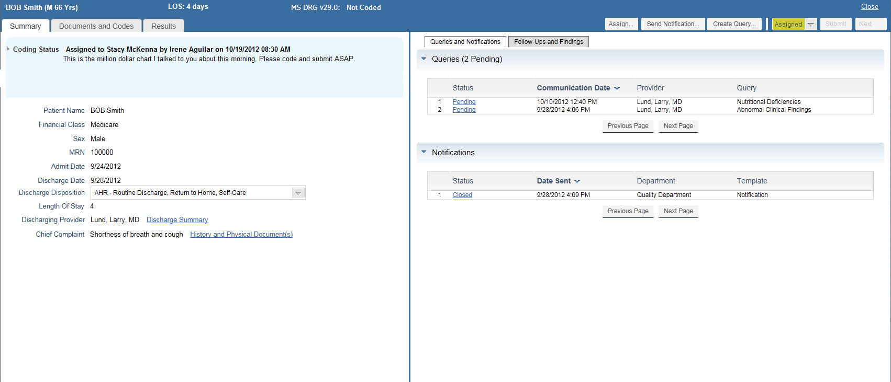

* + - 1. The above image depicts a record assigned to the coder. Assigned records are assumed “ready” to code. The coding status in DB is set to ‘Assigned’
      2. Available actions for assigned records:
         1. Code the record and submit (submit only available if a saved codeset from Codefinder is available) – Coding Status set to ‘coded’ when Submit button pressed

Submit Error Handling when accessing record from 360 worklist and interfacing to an abstractor (example, PowerAbstract) that requires sending a request to synchronize the encounter (requesting the abstractor to load their same record for the same visit we are loading)

If the User presses the Submit button and the call to the abstractor fails, a “Submit Synchronization Failed” dialog box displays.

The dialog box contains the following message “A failure occurred sending the submit associated with this record to your abstractor. Please press “Retry” to attempt to retry synchronizing the submit or press “Submit” to continue.

The following visit data displays below the message: VisitID MRN Patient Name Facility Admit Date Discharge Date

If the user presses “Retry” 360 resends the request synchronize the submit again to the abstractor. The user may attempt pressing ‘Retry” button multiple times.

If the user presses “Submit” button, the visit is placed on hold in 360 and 360 workflow continues as if there was not a failure synchronizing. This will result in the visit being placed on Hold in the 360 DB, the coding is saved in the 360 DB, and the will need to be re-accessed at a later time to complete the submission (from a Hold worklist).

* + - * 1. Place the record on hold – Coding Status set to ‘On hold’ in DB when Coding Status is changed to ‘On hold’
        2. Re-assign the record to a manager/auditor via the Assign… action button – Coding Status set to ‘assigned’ and ‘assigned user’ stores the name of the assigned user in the DB.
    1. IP Record On Hold (Coder View)

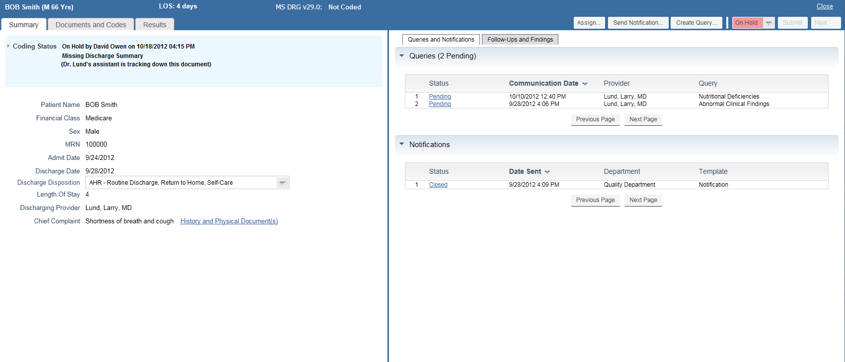

* + - 1. Selecting a record on hold from the Holds worklist presents the above view.
         1. Click on status dropdown to change status from On Hold to Ready. (Decision to make this a drop down list instead of a toggle based on need to have a visual indicator that a choice is available). A history of the coding status state changes is maintained. (example, movement of record from assigned, to hold, to coded). A record is only in one status at a time.
         2. Also recommend a keyboard shortcut be available to switch from On Hold to Ready as well as shortcut to move from Ready to On Hold.
      2. Available actions for the coder:
         1. Assign record to a manager/auditor
         2. Change record status to Ready
         3. Coder can still code the record while on hold but will not be able to submit codes until status has been changed to Ready.
         4. Submit can only be available when there is a saved codeset to submit; i.e. Done in Codefinder.
    1. IP Record Coded (Coder View)

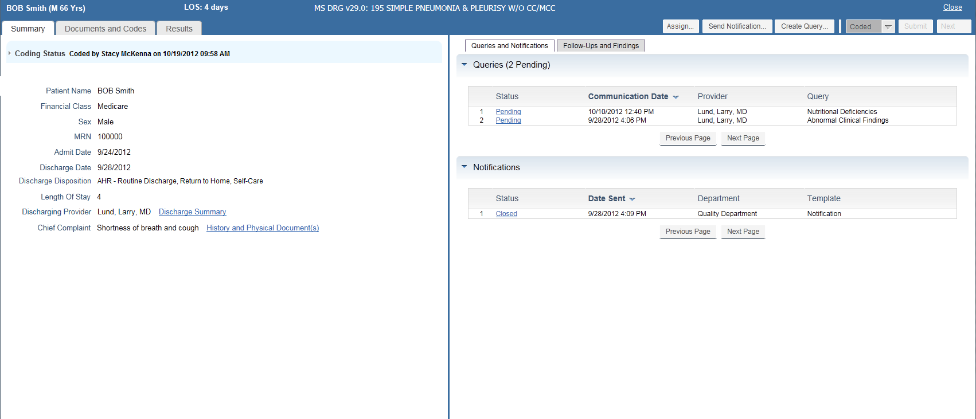

* + - 1. The above image depicts a record that has been coded- available to coders via the visit search function in the dashboard.
      2. Available actions:
         1. Set record to “Ready” state for recoding and resubmitting. Changing status to Ready will enable the Submit button since a saved codeset will exist. Subsequent submissions will create entries in the Coding Status log.
         2. Assign record to manager/auditor via the Assign action
  1. Visit Assignment
     1. In dashboard/worklist mode, users can assign visits to other users. Assignment can also be thought of as “routing” a visit to another user for their attention or completion.
     2. For beta, assignment is not available in launch-in mode.
     3. Managers assign visits to coders so that priority records are coded first or that visits can be routed to a coder with specialized knowledge or skill set.
     4. Coders can also assign visits to managers/auditors for their review. Managers can also assign visits to other managers/auditors. For example, to route a visit to a coder not on a manager’s team, the manager would assign the visit to that coder’s manager, who would subsequently route that visit to the coder.
     5. Assigned visits are placed in the user’s Assigned worklist.
     6. Assigned visits always take precedence when using the “Next” function within the workflow.
        1. Assigned visits should be ordered using the regular next ordering (within the assigned grouping). Coders also have the choice of selectively picking from the assigned worklists (since the visits have been assigned by a manager, individual selection can't be considered "cherry picking.")
        2. Hold records (if the coder is coding using Next from the hold list) should also use the regular next ordering within the holds grouping. We do anticipate the coders will selectively pick visits from the holds worklist.
     7. Multiple visits can be assigned to a single user, but only one user at a time can receive an assignment. I.e. it’s not possible to assign a record to more than one user at a time.
     8. Coders:
        1. Can assign visits only to managers or auditors. The users available to coders in the selection list are filtered to show manager/auditor users in First Name Last Name format for all enterprises/facilities in alphabetical order.
     9. Managers:
        1. Can assign visits to other managers/auditors.
        2. Can assign visits only to coders on the manager’s team (assigned to the manager).
        3. For beta – Managers/auditors aren’t assigned to other managers. A coder can be assigned to only one manager.
  2. Hold Visit (Dashboard Mode Only)
     1. When the coder changes the record status to On Hold, the coder will be presented with a model dialog to provide a hold reason and to add additional comments if desired. The hold reason is required. Hold comments are not required.
     2. The coder selects a hold reason description from the drop down menu.
     3. Hold Reason list is customizable by site.
     4. The comment box is a free text field where the coder can make any notes about the hold desired. Comment is not required.
     5. Hold Visit Actions
        1. Hold – the hold information is saved, and the application returns to the screen where the coder was when selecting – from this point the coder can continue to the work in the record, eventually clicking Next or selecting Close.
        2. Hold and Next - If the coder presses the ‘Hold and Next’ button, the application saves the hold information and all appropriate information in the record, and calls the next record from the worklist mode (if in worklist mode)
           1. If visit called from Open Visit or Patient Search, this option is disabled.
        3. Cancel - the hold information is not saved and the application returns to the screen from where the Hold Visit button was pressed.
     6. Hold Visit Dialog

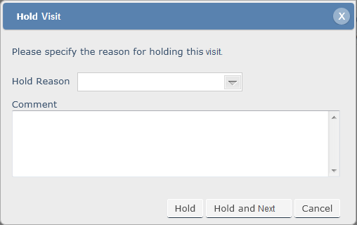

* + - 1. Terminology and workflow changes require the following changes to the “Hold Case” function:
      2. The function should be called “Hold Visit” not “Hold Case”
      3. The instruction “Please specify the reason for holding this case.” to be changed to “Please specify the reason for holding this visit.”
      4. Hold button places the visit on hold, returning the coder back to the visit. (Message sent to abstractor). The coder will close out of the session or click “next.”
      5. Hold and Close will change to “Hold and Next.” This function will allow the coder to place the chart on hold and obtain the next record in the worklist (same as selecting Hold, then selecting Next).
      6. Cancel abandons the hold operation, returning the coder to the visit record.
      7. Hold Error Handling when accessing record from 360 worklist and interfacing to an abstractor (example, PowerAbstract) that requires sending a request to synchronize the encounter (requesting the abstractor to load their same record for the same visit we are loading)
         1. If the User presses the Hold or Hold and Next button and the call to the abstractor fails, a “Hold Synchronization Failed” dialog box displays.

The dialog box contains the following message “A failure occurred sending the hold associated with this record to your abstractor. Please press “Retry” to attempt to retry synchronizing the hold or press “Hold” or “Hold and Next” to continue.

The following visit data displays below the message:  
VisitID MRN Patient Name Facility Admit Date Discharge Date

If the user presses “Retry” 360 resends the request synchronize the hold again to the abstractor. The user may attempt pressing ‘Retry” button multiple times.

If the user presses “Hold” or “Hold and Next” button, the visit is placed on hold in 360 and 360 workflow continues as if there was not a failure synchronizing. This will result in 360 DB and abstractor being out of synch in visit hold status.

* 1. Dashboard and worklist operations

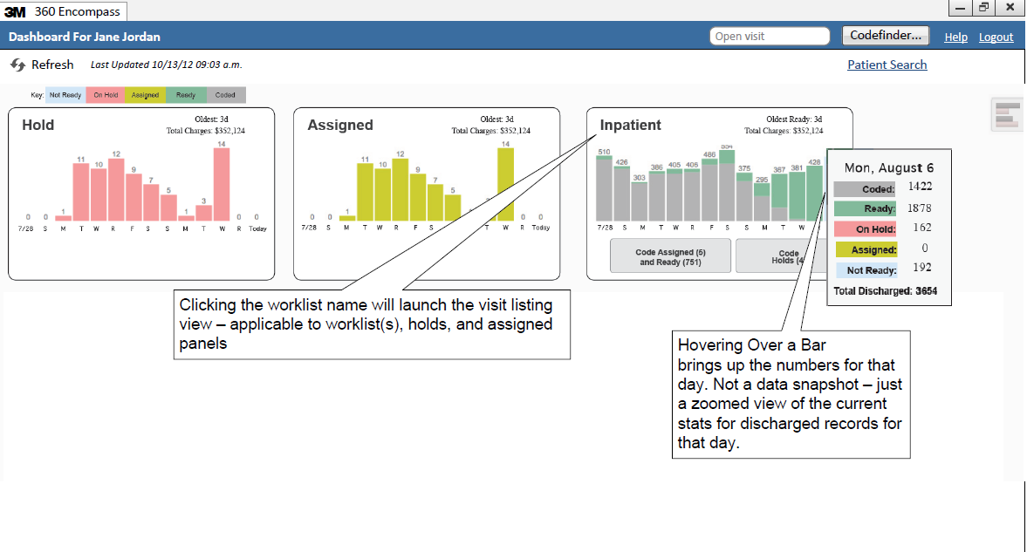

* + 1. Coding Dashboard (Home Dashboard) Features:
       1. Multiple worklists (or buckets) can be assigned to the coder. Hold and Assigned worklists will always be available and listed first as these represent all visits the coder placed on hold or that have been assigned by the coder’s manager.
       2. The bar graphs represent a rolling 14 day period starting with “Today” (current date) on the far right and extending right to left an additional 13 days. The far left date will be represented in m/d format.
       3. The coder can refresh at any time by clicking on the refresh link

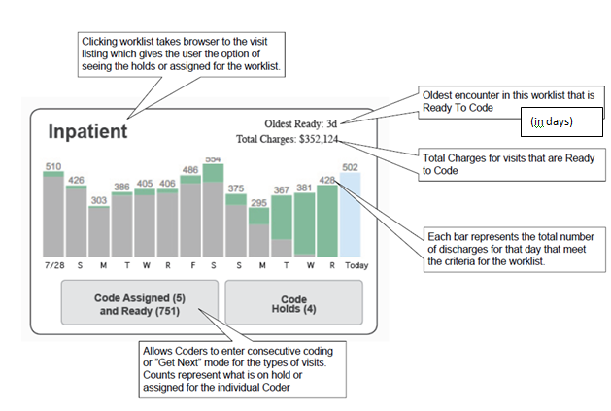

The worklist bar chart contains all records associated with the worklist configuration criteria. Records of all readiness states are included (not ready, ready, assigned, hold, and coded)

Coded Today represents the number of records coded by the coder or coders associated with the manager if worklist is for a manager.

(Add as additional button next to Code Holds)

**Coded Today (7)**

* + - 1. The coder’s individual productivity statistics for all worklists are available by clicking on the productivity stats icon in the upper right corner.
      2. A specific visit can be accessed via the Open Visit field in the ribbon at the top.
      3. A standalone session of Codefinder can be invoked.
      4. A link to the Patient Search function is available. Use existing Patient Search design.
         1. The workflow that is invoked will depend on the topic of the tab being displayed when the patient search function is called.
      5. Hover over (with .5 second delay) provides a zoomed in summary of the stats for that day.
         1. Mouse-over statistics not applicable to Hold or Assigned worklists.
      6. Visit listings for coding worklists display only Hold and Assigned.
         1. Hold and Assigned worklists have unique behaviors. (accessed by clicking on the Hold or Assigned bar graph)
         2. These represent the visits placed on hold by the coder or assigned to the coder. There is one Hold graph and one Hold worklist. Coders can only see visit listings for charts assigned/routed to them or that they have put on hold to prevent coders from picking specific charts from the list to code.
         3. At this level (home dashboard), they represent all holds or assigned for the coder across all worklists, including assignments from worklists that the coder isn’t normally assigned to. (example select * from visits where assigned=<logged-in user>)
         4. Holds and Assigned allow access to the visit listings by clicking on the panel itself.
         5. Logged in User = Coding Manager. If the Individual filter is selected, the Holds/Assigned are for the manager specifically. If Entire Team is selected, Holds/Assigned are aggregated for the coders assigned to manager plus the manager's on holds and assigned..
         6. Coders can assign charts to managers to resolve questions. Managers can assign charts to coders or other coders with more specific knowledge to help code the chart or to balance workflow.
      7. If the user clicks on the Coded Today button, the visit listing displays with an additional tab of “Coded Today (#)”
      8. Coding Dashboard Tab labels:
         1. Coding Dashboard
         2. Coding Worklists
    1. Coder Productivity

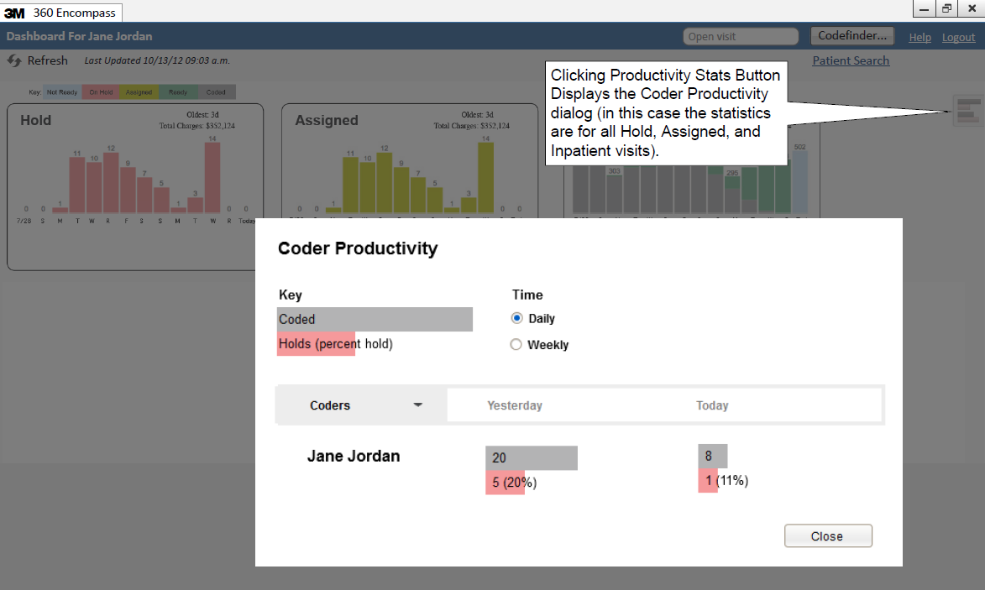

* + - * 1. The productivity definitions below apply to individual users only, no aggregate work team counts. The calculations are based on the current selected view (All, specific worklist, holds, or assigned). In the image to the left, the statistics would be calculated for the coders Holds, Assigned, and Inpatient lists.

Note that Managers/Auditors can view the statistics for their team members.

* + - * 1. Coded = Volume of visits coded in the selected timeframe
        2. Holds = Volume of hold update actions include putting visits on hold or updating hold status for the selected time frame.
        3. Holds Percent = Volume of hold cases updated as a percentage of the visits worked for the selected time frame (coded + holds)
        4. When Daily option is selected:

Yesterday = Volume of visits transitioned to coded state by a coder at any point in the previous calendar day. If a coder goes back and resubmits a visit, it is only counted once (DISTINCT on visitID). If the coder who resubmits the visit is different than the original coder, the 2nd coder (the one who resubmitted) is counted. I.e. both coders get credit but only once (to prevent frivolous resubmissions to improve productivity scores).

Today = Same as “yesterday” but for current calendar day.

* + - * 1. When Weekly option is selected

Last week = Same as “yesterday” but for previous Sunday through Saturday.

This week = Same as “yesterday but for current week beginning on Sunday.

* + 1. Coder Worklist Visit Listing View

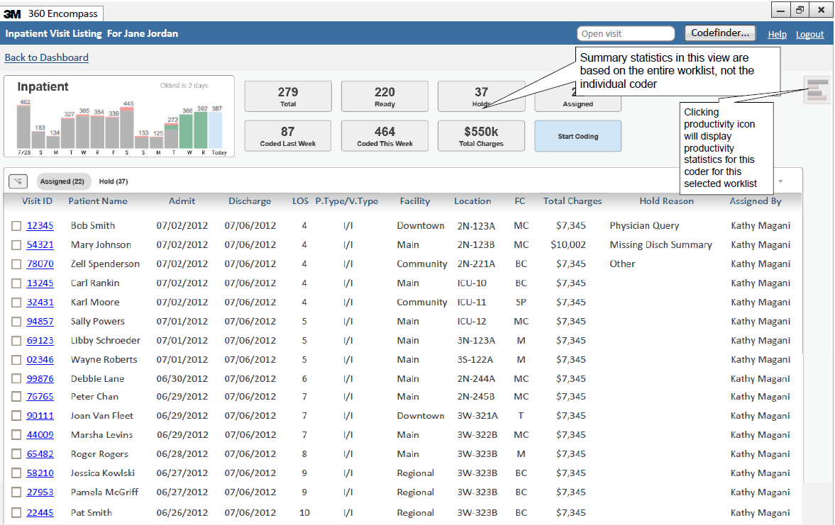

Tabs: All, Assigned, Ready, Hold, Coded Today

Clicking on a tab displays the records associated with the tab’s readiness state.

Default tab selected: Assigned

Records listed by default based on sort order defined in worklist definition.

**Coded Today (7)**

Oldest Ready = 3d 3= 3d

* + - 1. For coders, the visit listing provides a row by row listing of records in either hold, ready, assigned, or coded today status for the coder for the selected worklist. If there are no visits from the selected worklist that have been explicitly assigned to the coder or placed on hold by the coder, meet the worklist readiness criteria, or coded today by the coder the result set will be empty (no visits). Records with a readiness status of “Not Ready” do not appear on a visit listing.

Invoked by clicking on worklist name in the summary panel in coder worklist view

Defaults to displaying the “Assigned” tab

Provides listing of visits assigned to the user, in a ready state, on hold for the user, or coded by the user for the selected worklist.

Available user actions are:

Start Coding (same as invoking Start Coding from worklist summary panel). Get next mode is activated.

Records are surfaced based on coding readiness state.

“Assigned” records are surfaced first, followed by “Ready” records.

Within each readiness state grouping, records surfaced by sort order – defined in worklist definition or if manually re-sorted, records surfaced in clicked on order displayed in visit listing

Records with a readiness state of “Not Ready”, “Hold” or “Coded” are not surfaced in Get Next mode. Hold records need to be selected individually by coders.

If all ready/assigned visits are coded and the only non-coded records are those on ‘Hold”, the worklist should be considered exhausted for Getnext.

Assign selected visits to a manager or auditor

Switch between All, Assigned, Ready, Holds, or Coded Today visits by clicking on a different tab. The All tab contains all records in Assigned, Ready, Hold or Coded Today state.

Apply column filters

View individual productivity statistics for the selected worklist.

Return to coder’s home dashboard by clicking on “Back to Dashboard” link.

Coders can use the column headers to sort the visit listing as desired

Coders can launch any of the visits by clicking on the VisitID link.

Syntax for ribbon header

[Worklist name] Visit Listing for [Coder] formatted as First Name Last Name (e.g. Jane Jordan)

Associated with each worklist,

* + - 1. In addition to the displayed columns from the image, please add
         1. Assigned Comment
         2. Hold By
         3. Hold Reason
  1. Assignment of Visits by Coders

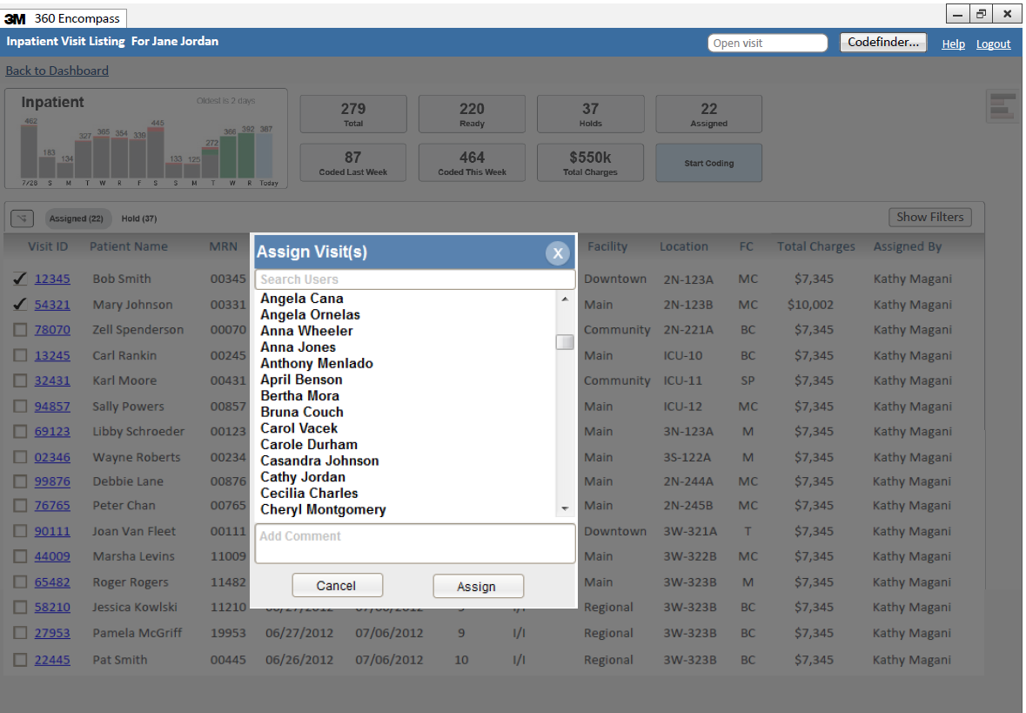

* + 1. Coders can reassign visits to managers/auditors only. Only visits that are currently on hold or assigned to the coder can be reassigned.
       1. In the example above, the first two visits have been selected for routing to a manager.
       2. Steps involved in assigning a visit:
          1. Coder selects the individual visits to assign using the checkbox.
          2. Coder clicks the assignment icon.
          3. Coder selects or searches for the coding manager or auditor in the popup search dialog (only manager/auditor (active for all enterprises/facilities) users (first name last name) will appear in this list in alphabetical order.) Coder selects the manager or auditor to whom the assignment will be made. All users having the coding manager role appear in the list, even those managers to whom the user does not report.
          4. Coder optionally adds a comment that will be applied to all visits selected for assignment.
          5. Coder selects “Assign” (or cancel to abandon the re-assignment)
       3. After assignment, the displayed list will be refreshed automatically to show the updated listing.
  1. Coding Manager Dashboard

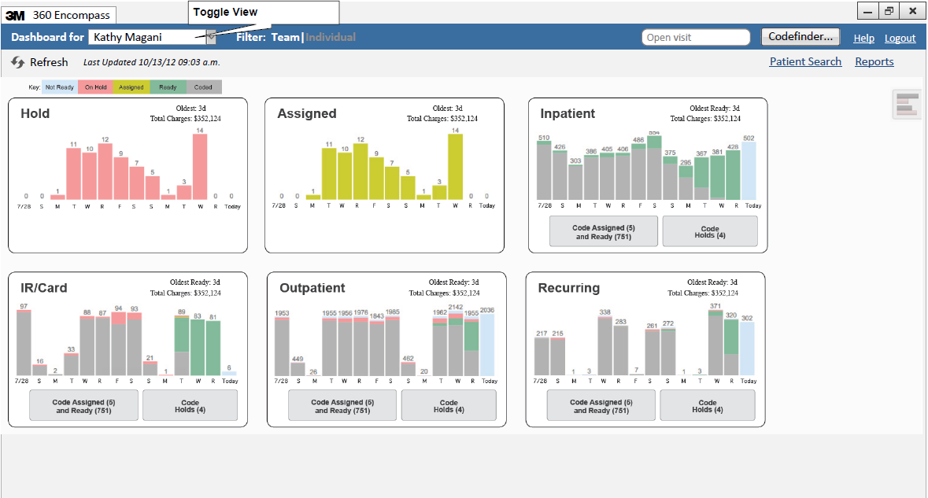

* + 1. The Coding Manager dashboard is intended for users with coding manager permissions, as configured in the user management. The following features are available:
       1. View dashboards for other managers and coders via the toggle view.
       2. Filter display either by the manager’s team or the manager’s individual work.
       3. Access a specific visit by entering the visit ID in the Open Visit function. The workflow that will open will depend on the type of dashboard tab being viewed - e.g. if the manager is viewing a CDI dashboard and uses Open Visit, the record will open in CDI worklflow. If user is viewing a coding worklist, the visit will open in the IP or OP workflows, depending on visit type.
       4. Launch a standalone session of Codefinder (standalone = not linked to a patient visit record in the 360 database)
       5. Invoke the patient search function
       6. Access the reports view. The following categories of reports are:
          1. CDI Reports
          2. Indicators Reports
          3. Coding Reports
          4. System Administration Reports
       7. Refresh the dashboard via the refresh function
       8. View productivity statistics
    2. Generally speaking the coding manager dashboard provides the same functionality to the manager as the coder dashboard except with additional management functionality:
       1. Productivity statistics are available across the manager’s work team (coders, managers, and auditors assigned to the manager)
       2. Each worklist provides a visit listing (by clicking on the worklist name in the summary card. The visit listing provides the manager with the ability to assign visits individually or in bulk to specific coders, auditors, and managers.
    3. Manager Productivity Statistics

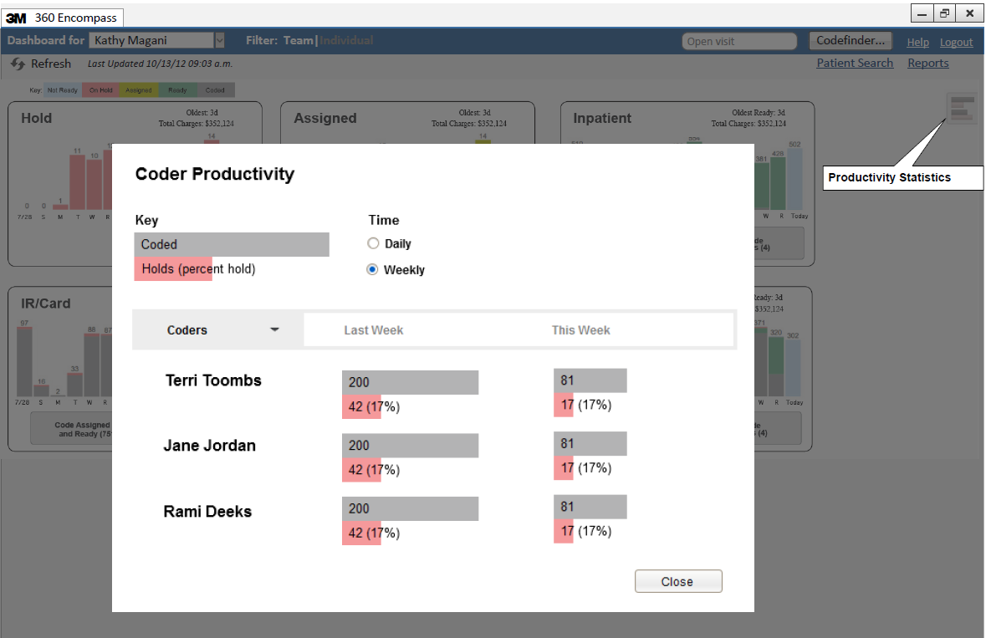

* + - 1. Manager productivity statistics function essentially like individual coder statistics with the additional capability of viewing the manager’s team’s statistics.
         1. Coded and Holds statistics are the aggregate of the entire team
         2. The manager herself is just another name in the team list.
         3. A vertical scroll bar appears on the team list.
    1. Manager Toggle View – Available Options and Functionality
       1. Manager name + Team filter (default view) provides worklist panels for Holds, Assigned, and all Worklists assigned to the manager and/or the coders assigned to the manager – as depicted on the previous page. Essentially, all work assigned and available to the manager’s team is available in this display. Note – it will be Dev’s discretion whether the manager’s team’s worklists need to be assigned to the manager explicitly or implicitly via the worklists assigned to the individual coders assigned to the manager. Through this view, managers can access the visit listing for any of the worklist panels as well as access the team productivity statistics.



* + - 1. Manager name + Individual filter provides the manager’s Holds and Assigned visits – specifically for the manager. Productivity statistics display just the manager’s individual productivity statistics as a coder (same view as individual coder productivity statistics).



* + - 1. Another manager’s name (only Team filter is available) provides viewing of the Holds, Assigned, and Worklists panels for the selected manager’s team. NOTE: If I am a manager, and I'm viewing the dashboard of another manager, I am only able to view the worklists in that other manager's dashboard, but not assign, hold, or code from any of those worklists even if I am assigned to any of the same worklists as that other manager. If we share a worklist, I would go back to my own dashboard, and make an assignment, or launch a record for coding from there.



* + - 1. All Managers (only Team filter is available) provides access to the Holds, Assigned, and Worklists panels for all managers. NOTE: If I am a manager, and I'm viewing the dashboard of another manager, I am only able to view the worklists in that other manager's dashboard, but not assign, hold, or code from any of those worklists even if I am assigned to any of the same worklists as that other manager. If we share a worklist, I would go back to my own dashboard, and make an assignment, or launch a record for coding from there.



* + - 1. Manager Toggle View
      2. The manager toggle view, available only to users with coding manager permissions, provides the ability to switch the perspective of the contents of the dashboard, worklists, and productivity statistics.
      3. The “Dashboard for” dropdown list will contain the names for all users designated as coding managers or auditors. Additionally, there is an “All Managers” option in the dropdown list.
      4. The “Filter” toggle switch allows the manager to interact with “Team” information or the manager’s individual information. The Team|Individual filter does not apply when viewing other managers’ information or the All Manager option.
      5. **Important: under no circumstances can a manager code, assign or hold a record from another manager’s worklist.**
    1. Manager Worklist View

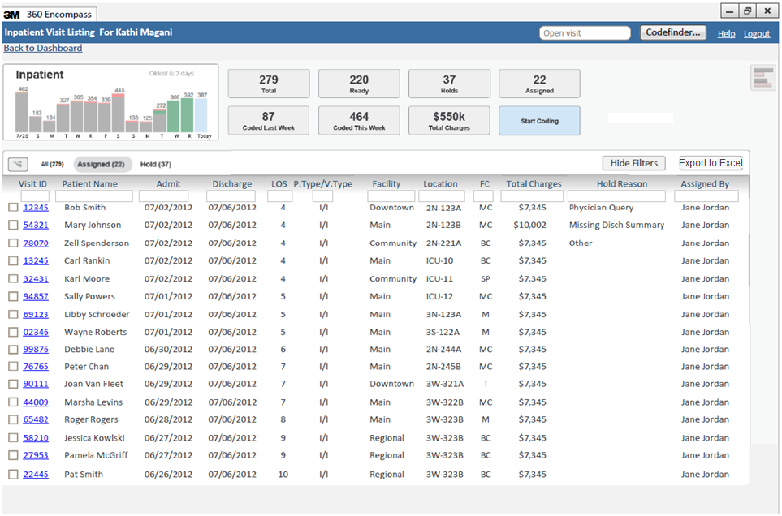

Tabs: All, Assigned, Ready, Hold, Coded Today

Clicking on a tab displays the records associated with the tab’s readiness state.

Default tab selected: Assigned

Records listed by default based on sort order defined in worklist definition.

* + - 1. Important: assigning visits to coders or coding records from a worklist can only be performed by the manager if the worklist is assigned to the manager – otherwise the worklist view is essentially view only.
      2. Worklist View provides the following capabilities:
         1. Switch between tabs: All, Assigned (to the manager), Ready, visits on hold (by the manager), or Coded (by manager or coders associated with the manager)
         2. Assign visits to team members
         3. View team productivity statistics for the worklist
         4. Sort display by columns
         5. Apply filters
      3. Export to Excel (supported versions Excel 2007 or greater)
         1. Provide the ability to export the visible worklist (after any column filters have been applied) to format. If the number of rows associated with the worklist extends beyond the first screen of display, all pages associated with the worklist are exported.

The entire result set (after filters applied) should be exported, not just the visible data.

The export should include the column headers from the worklist in addition to the data, but no other header information needs to be generated, e.g. not necessary to provide the worklist name, user, or date.

* + - * 1. If user selects Export to Excel, open data from worklist in Excel.

If Excel not available on device, prompt with message “Excel not available on this device” or similar message.

* + - * 1. User will use Excel’s file management features, such as Save, Save As to manage the resulting spreadsheet.
    1. Assigning Visits
       1. Assign visits functions just like the coder assign visits with the following extensions:
       2. Managers can assign visits to any of their team members or other managers/auditors
          1. For example: if two managers agree to transfer work from one group to another across work teams, the first manager would assign the visits to the second manager. The second manager would then assign the visits to her team. I.e. it shouldn’t be possible for a manager to assign visits to coders not on her team.
    2. Worklist Summary
       1. Coded (Grey), Ready (Green), Assigned (Yellow), On Hold (Red) and Not Yet Ready (Blue) for this worklist.
       2. Data represents all accounts that are visible to the user. For a manager in Team mode, the data represent all visits visible to the user or the users the user manages.
       3. The Holds and Assigned values on the graph are what are assigned or on hold for the entire worklist (not filtered by coder)
  1. Worklist configuration
     1. Roles/Workflow Access
        1. 360 Encompass Phase II supports the following roles:
           1. System Administrator (special case – see <??> below)
           2. CDI Manager
           3. CDI Reviewer – needs to be assigned to a manager
           4. Coding Manager
           5. IP Coder – needs to be assigned to a manager
           6. OP Coder – needs to be assigned to a manager
        2. Manager assignment
           1. For the roles of CDI Reviewer, IP Coder, or OP Coder, a manager must be specified for each role available to the user.
           2. Coding Managers and CDI Managers are not assigned to managers (i.e. only one level of manager-staff relationship can exist), but it is possible for a user to be both a CDI Manager and Coding Manager at the same time.
           3. The multi-role user will report to one manager. If a user performs both CDI and Coding, most likely that user's manager is also responsible for both activities. I.e. the software does not need to support users having more than one manager.
        3. Each user account can have access to more than one workflow. Which workflow is invoked will depend on the context in which the patient record is accessed (search patient﻿ and open visit will use the context of the workflow associated with the dashboard/worklist being viewed at the time that Search and Open Visit were called).
           1. CDI: For beta, the CDI/Analytics workflow is invoked when a patient record is selected from a CDI or Analytics worklist.
           2. Coding:

in launch-in mode (from 3rd party abstractor), either IP or OP coding workflow is invoked when the record is called by the WebLink API with Codefinder. Whether IP or OP is invoked will depend on a system configuration associating visit types to IP or OP coding.

In 360 worklist mode, the IP or OP coding workflow is invoked when the record is selected from a coding worklist. Similar to launch-in mode, which workflow is selected will depend on the visit type mapping.

* + - * 1. Analytics: for beta – Analytics is part of the CDI workflow. A separate analytics-only workflow will be deferred to a post-beta release.
      1. Manager functionality
         1. A CDI Manager has all the functionalities of CDI Reviewer plus any CDI Manager specific functionalities (e.g. ability to see daily review activity statistics in the dashboard).
         2. A Coding Manager role has all functionalities of Coder. For beta, Coding Managers and Auditors will have same level of functionality and access. I.e. there is no separate “auditor” role for the beta release.
      2. System Administrator functionality
         1. Current 360 phase-II (i.e. card-based) admin configuration approach for facilities will be re-used. If the logged-in account is mapped with “Administrator” role, then the card-based admin UI will be launched instead of the 360 tab-based UI. I.e. for admin functionality we will use the card-based UI for beta.
         2. It is not necessary to support single sign-on for system administrator access.
         3. The Users Manager feature in current phase-II design will be re-used for creating/updating user accounts and assigning access to roles/worklfow Important – for beta, it is not required that a system administrator account also have access to dashboards and workflows. Should an individual require system admin and workflow access, separate accounts need to be established.
    1. Worklist Definitions
       1. System administrators define and assign worklists.
       2. Coding worklists are built using worklist criteria templates.
          1. Templates provide a selection of pre-defined criteria from which to choose.
          2. Any number of criteria can be combined to produce the desired result set.

For example, users can build a worklist where visit.facility in (“facility1”, “facility2”) AND visit.visit_type in (“IP”).

* + - * 1. For beta, it will not be possible to use any other criteria than what will be provided through the worklist builder UI.

If a customer’s worklist needs cannot be met via the pre-defined criteria templates, the worklist builder function may be extended by Development as an enhancement.

The goal of this strategy is to provide a consistent and “best practice” worklist methodology to the market.

* + - * 1. For beta, the design goal for defining worklists is to present admin users with a view similar to the existing Search Patient view (in the tab-based UI).

The worklist criteria will be saved and named (think: bookmark) as the name of the worklist. That will be the worklist definition.

When that worklist is on a dashboard, and needs to be refreshed, the generated SQL from the definition will execute, and the visits that match the "search" conditions of the definition will be returned.

NOTE: for beta, the UI of the worklist builder is left to Dev’s discretion, provided the design supports the worklist requirements.

* + - * 1. If a criteria choice is not used, it is assumed that records are not filtered by that criteria.

For example, it will not be necessary to select all facilities if a worklist definition applies to visits from all facilities. In this case, the facility criteria will be omitted.

* + - * 1. The values for configurable conditions should be exact matches to the stored value.
        2. Customer use of SQL wildcard operators are not supported.
        3. Some criteria will involve GREATER THAN or LESS THAN operators (e.g. total charges > $10,000.)
        4. It is desired (but not required for beta) to be able to use the SQL “NOT” operator for any criteria choice to produce the inverse result set. E.g. all records where visit.facility NOT “facility1”.
        5. The outcome of all criteria selections will be a series of SQL “AND” or “AND NOT” conditions. SQL “OR” criteria are not explicitly supported nor are nested criteria (with the exception of behind the scenes SQL statements generated by the worklist builder UI to generate the desired query).
        6. “Security filters” applied to individual users are supported and potentially will impact the result set of any worklist for that user. (Facility Only) Need to retrofit CDI and Analytics dashboards to match.
      1. Customer responsibilities: Customers are responsible for defining a worklist strategy such that all records desired to be coded are represented.
         1. Customers will be responsible to ensure that worklist definitions and assignments follow whatever data security (related to worklist conditions) that the customer requires.
      2. Worklist assignments:
         1. Any worklist can be assigned to a manager directly, or to a team member of a manager, and that both assignments will cause the worklist to appear on the manager's dashboard.
      3. A visit can appear on multiple worklists simultaneously if it meets the customer-defined conditions of multiple worklists simultaneously.
      4. **Coding Status:** A visit, no matter how many worklists it appears on, can be in only one coding status - Not Ready, Ready, Assigned, On Hold, Coded. Note: launch-in mode supports only “Ready” (default) or “Coded” statuses.
      5. Coding Worklist Criteria Templates: Include definition of the following components of each worklist: Coding Readiness Criteria, Worklist Criteria, Assigned Users, Worklist Grouping and Sort Order for default sort order on Visit Listings.
         1. **Coding Readiness Criteria:** Each worklist will include a set of customer defined “coding readiness” criteria that will be used to determine the coding readiness state for the visits associated with the worklist. This criteria will be used on coding dashboard for identifying coding state for bar charts and for visits to display on each tab associated with the Visit Listings. Coding Readiness criteria will be a combination of

Hours Since Discharge: Elapsed time (measured in hours) since discharge

CAC Documents: The presence or absence of specific CAC document types.

Total Charges: The presence/absence of total charges.

Per worklist, customers may use one, all, or none of these coding readiness criteria. Because different worklists will represent potentially different visit types, the readiness criteria will be specific for each worklist instance (bucket). For example, the readiness criteria of “72-hours post discharge AND discharge summary report available, and total charges available” should be a valid readiness test for a visit. Otherwise the visit is “Not Ready.”

Important! In launch-in mode, “readiness” does not apply, and all visits are initially set to “Ready” until they are switched to “Coded” when the coder submits the codes by selecting “Submit and Close.”

If no readiness criteria is defined for a worklist, the visit will be considered ‘ready’ if it has a discharge date.

Coding readiness does not apply to visits without a discharge date (so that concurrent coding worklists may be configured).

* + - * 1. **Worklist criteria:** Each worklist will include a set of customer definable criteria for determining which visits are included in the worklist. The user may select any combination of the following database elements in defining the worklist:

Discharge Status

Formula: Where visit.discharge_date is not null (to allow for concurrent coding) “Yes” or “True” = patient is discharged, “No” or “False” = patient has not been discharged.

Facility

Multiple selection based on visit.facility

Patient Type

Multiple selection based on visit.patient_type

Visit Type

Multiple selection based on visit.visit_type

Location

Multiple selection based on current/discharged location

Department

Multiple selection based on department associated with attending physician

Total Charges

Greater Than threshold value (positive integer value entered by user)

Coding Status

Multiple selection based on current coding status

Financial Class

Multiple selection based on visit.financial_class

Assigned

Special case worklists based on individual visit assignment (routing) from one user to another (see assignment requirements later in document)

On Hold

Special case worklists based on individual visits placed on hold by users.

For all coding worklists, once the visit has been coded (status = “Coded”), the visit will no longer appear in the worklist.

Support Pending Queries holds.

* + - * 1. **Assignment override:** managers can assign visits to coders (via the visit assignment function) that would not normally appear on their regular worklists. These assignments will appear in the "assigned" list for that coder. Assignments by managers will, in effect, override user-level security filters (facility access).

From Open Visit – the assignment will happen by opening the visit and selecting the “Assign” button.

From Search Patient – the assignment will occur by opening the visit and selecting the “Assign” button.

For beta – it is not required that managers be able to assign visits using Open Visit or Search Patient functions.

* + - * 1. **Worklist Grouping and Sorting**

Each worklist will be sorted by the sorting columns defined in the worklist configuration. For example, if the following columns are selected:

Discharge date (rounded to date only, not time), sorted oldest to newest

Facility

The sort order within each grouping will be total charges, highest to lowest

The outcome should be that coders will be working on visits from the same discharge date across all facilities represented by the worklist. This strategy ensures an even distribution of backlog across the enterprise.

Worklists configuration

These requirements are a hedge to get us started on implementation, but they could change (although they are unlikely to) in the near future based on customer feedback.

Beta customer has decided to implement multiple worklists representing various groupings of facilities without the need to tie them together in any fashion. Multiple worklists will be assigned to a coder and displayed on his or her dashboard. Coders will be instructed to complete all the ready records on their “level 1” priority worklist before beginning to code from their “level 2” worklists. Worklists will not be called “level 1” or “level 2” or “level 3” but something else more appropriate to the grouping of facilities. The naming of the worklists is an implementation issue not a development issue.

A coder can have any number of worklists assigned to them and a record can appear on more than one worklist, although a record can have only one coding status at a time regardless of the worklists in which it appears.

Although visits can appear on multiple worklists, they can still only be opened by one user at a time.

Worklists configuration must support the following featuresWorklist configuration capabilities as they presently exist, but using parameters (selection criteria) as described elsewhere in this document (as opposed to using the same parameters as CDI or Analytics worklist templates)

The ability to change the order of parameter selections in the multi-select controls (e.g., using up/down arrows to change the order in which the selected parameter values are listed in the control).

A list of all columns that are part of the query’s select statement, that can be selected into a selections control like parameters or assigned users are selected into a selection control. Each selected column can be marked as ascending or descending.

Default sort order of the worklist (visible or invisible) is based on the list selected list of sort-order columns. Facility, when selected as a sort-order column should follow the selection order of the facilities in ascending order (i.e., ignore the ascending/descending flag for facility).

For invisible worklists, GetNext should use the default sort order (as defined by the customer). For visible worklists, GetNext should use the visible sort order (i.e., default to start with, but sorted/filtered if the user has sorted/filtered the grid).

Clicking the Refresh link/button should reset a visible worklist to the default sort order.

Any worklist query that is executed should be filtered automatically by the executing user’s facilities data filter (i.e., dbo.Mpaspnet_UserToFacilities).

Following is a pseudo-design to meet the above worklists configuration requirements

Add a new worklist, and give it a meaningful name. (As it works now.)

Facilities specified in facilities param filter the records that appear in the worklist. (As it works now.)

Order of the facilities specified in the facilities param can be changed (i.e., facilities can be moved up/down in the selected list). This represents the sort order of the facility whenever facility is part of the sort definition.

Selected columns (from the worklist template query) are available for selection into a sort order. Any column can be selected into the sort order, any column (except facility) can be tagged as ascending or descending sort, and the order of the columns can be changed (to change the position of the sort--e.g., primary, secondary, tertiary, etc.).

The list of columns can be hard-coded can be hard-coded for now, or they can be a comma-delimited list in a new field that would be added to the dbo.ng_WorklistTemplates table.

The order by clause should be built based on the selected columns, in the selected order, with the selected direction (ascending or descending, except for facility, which is always in ascending order in the order of selection in the facilities parameter selection control).

This should happen at compile time—there is no need to have a dynamic query.

Users are assigned to the worklist. (As it works now.)

User-facilities data filter applies to the worklist.

Default sort order of the worklist (visible and invisible) is based on the specified sort columns, ascending or descending per column. If facility is one of the sort columns, facility sort order (defined by the order of facilities in the facilities param) applies to just that column, always ascending order.

For visible worklists, user can change sorting/filtering, and GetNext will respect that. (As it works now.) User can get back to the worklist-defined sort order by refreshing (e.g., by clicking the Refresh button/link). (As it works now.)

Following are use cases that must be supported by the worklists configuration, and which are supported by the requirements in this document:

Mary is a coder whose facilities data filter includes facilities A, B, and C. Her worklist needs to include records from A and C, and the order in which records are served to her should be discharge date, facility (C then A), and total charges descending.

Sue is a coder whose facilities data filter includes facilities C, D, and E. Her worklist needs to include records from C, D, and E, and the order in which records are served to her should be discharge date, facility (D then C then E), and visit key (to add entropy to the mix to avoid giving the first coder in the door too many hard records)